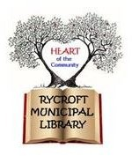
Application To Be A Member of the Village of Rycroft Library Board

Library Bylaw

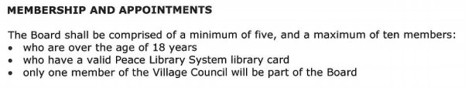

I would like to be considered for the Village of Rycroft Library Board

Name:……………………………………………………………………………………………..

Physical Address:………………………………………………………………………………………….

………………………………………………………………………………………………………..
Mailing Address:………………………………………………………………………………………….

………………………………………………………………………………………………………..
Phone:…………………………………………………………………..
Email:………………………………………………………………………………………………

Circle Yes or No

Are you over 18? Yes or No Do you hold a valid library card? Yes or No Will you be willing to volunteer at functions and events as time permits? Yes or No I understand that a requirement is a criminal record check. Yes or No I understand that the Village of Rycroft Council has to approve this application. Yes or No

(see reverse)

Why would you like to be on the Village of Rycroft Library Board?

Do you have any experience and skill set that will benefit the library and the community?

Drop completed application off at the Rycroft Municipal Library

Revised 21 Oct 2021

